- Write a programme in openGL/p5.js to illustrate camera motion and perspective.
https://p5js.org/reference/#/p5/camera
https://www.openprocessing.org/sketch/740258
https://www.youtube.com/watch?v=BW3D9WwalQE&list=LL985e97-NVkyBHbZDyLTnlA&index=3155&ab_channel=TheCodingTrain
https://p5js.org/reference/#/p5/perspective

let scroll = [];
let x;
let y;
let z;
let p = 20;

function setup() {
createCanvas(400, 400, WEBGL);
for (var i = 0; i < 3; i++) {
if (i === 2) {
scroll[i] = createSlider(15, 400, 200);
} else {
scroll[i] = createSlider(-200, 400, 0);
}
p = map(i, 0,5, 10, 100);
scroll[i].position(50, height+p);
scroll[i].style('width', '300px');
}
}

function draw() {
background(60);
x = scroll[0].value();
y = scroll[1].value();
z = scroll[2].value();
camera(x, y, z, 0, 0, 0, 1, 1, 1);
fill(255,69, 0);
cylinder(50,100);
}
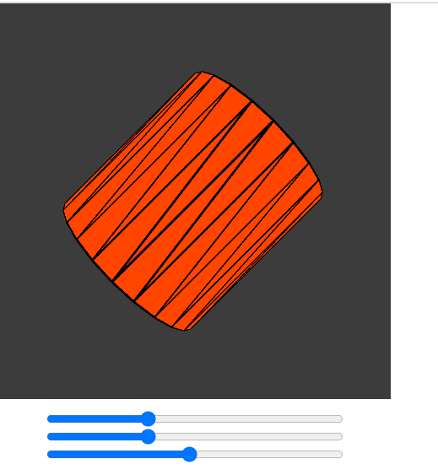

function setup() {
createCanvas(500, 500, WEBGL);
perspective(PI/4,1,250, 2000);

}
function draw() {
background(200);
orbitControl();
fill(255,0,0);
rotateZ(-0.5);
rotateX(-0.9);
rotateY(-0.4);
translate(-20, -70, -50);
push();
translate(-65, 0, tan(frameCount /25) * 120);
cone();
pop();
push();
translate(-45, 0, tan(frameCount /50 + (PI/5)) * 110);
sphere();
pop();
push();
translate(-15, 0, tan(frameCount / 30) * 95);
box();
pop();
}
